Juan Pablo de Legarreta
NETC-280
January 13, 2026
Lab 1 Assignment
- Use the Internet to find the following hardware manuals for our lab.
  - Cisco 3650 Switch
  - Cisco 4221 Router
  - Cisco ASA 5516-X Firewall
  - Dell Optiplex 8050 PC
Create a folder, labeled hardware, that includes the .pdf files from above
- Hardware can have one of many different firmware versions. To aid in troubleshooting, it is critical to determine the current firmware version that a piece of networking hardware is using:
  - For the Cisco devices above, collect the following information:
    - Serial number
3650 Switch:
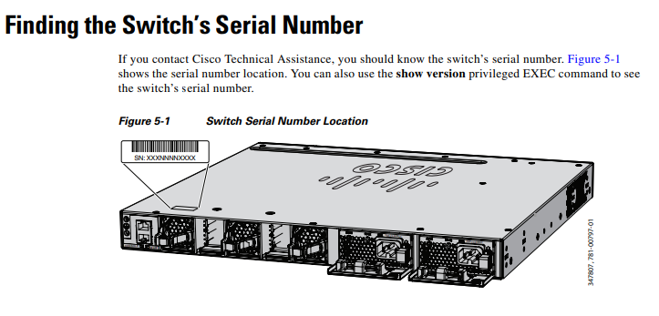
Finding the Switch’s Serial number, taken from the hardware manual.
4221 Router:
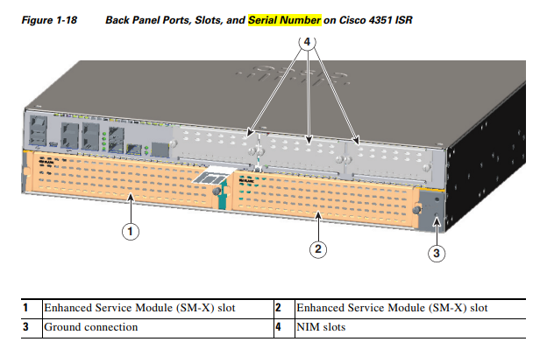
Finding the router’s serial number, taken from the hardware manual.
ASA 5516 X Firewall:
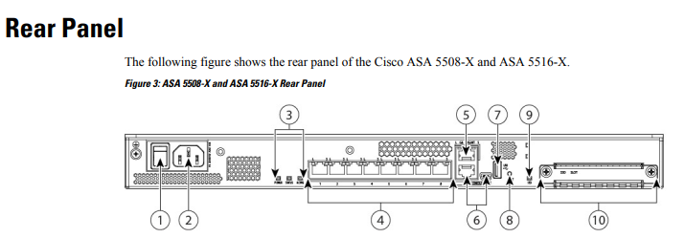
Where to locate the serial number for the ASA 5516 X, taken from the hardware manual.

    - Firmware version
3650 Switch:
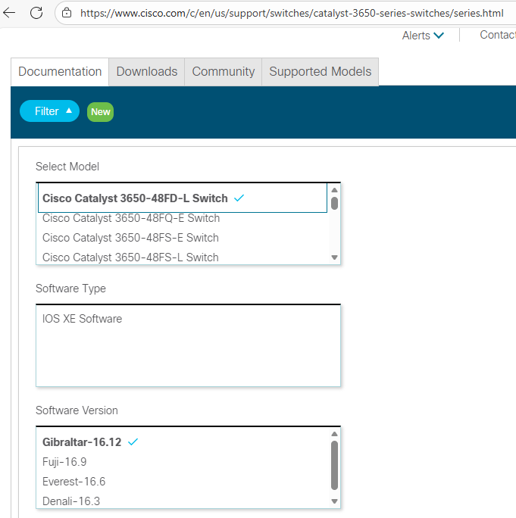
The latest available firmware for the 3650 Switch is Gibraltar-16.12, taken from Cisco’s website.
4221 Router:
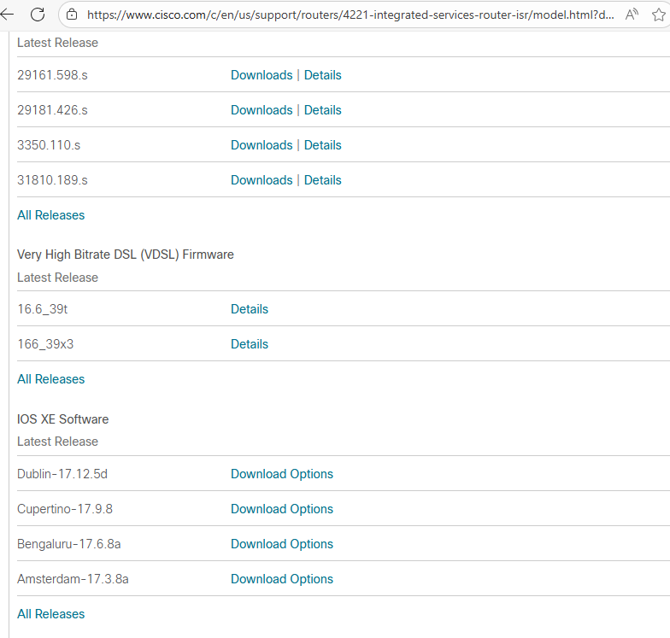
The latest available firmware for the 4221 Router is Dublin-17.12.5d, taken from Cisco’s website.
ASA 5516 X Firewall:
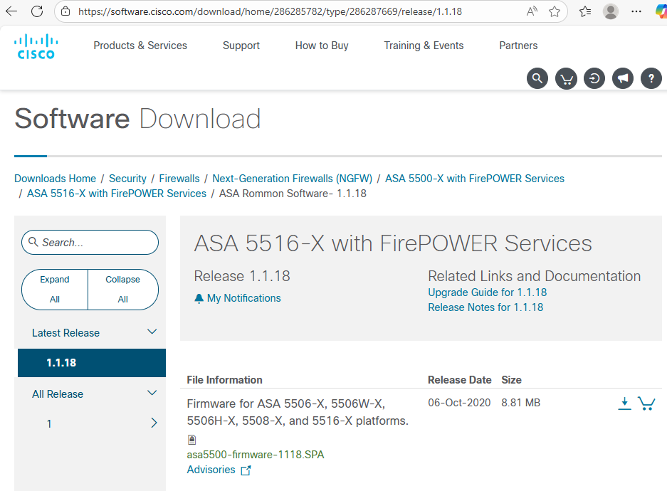
The latest available firmware for the ASA 5516 X Firewall is version 1.1.18, taken from Cisco’s website
- Use the SANS CIS document on the 20 critical controls to answer the following questions:
  - What is a security control?
A security control is a cyber defense best practice that provides specific and actionable ways to protect against cyber attacks.
  - Explain the difference and rationale of the different Implementation groups.
Within the SANS CIS Security Controls, there are three implementation groups named IG1, IG2, and IG3. These implementation groups contain different safeguards that create a prioritized guide to implementing the CIS Controls.
IG1 contains a foundational set of safeguards that are considered essential cyber hygiene. IG1 contains the 56 safeguards with the highest priority. IG2 contains a broader set of 74 additional safeguards that builds on IG1’s 56, and IG3 contains all 153 safeguards outlined by SANS. IG2 contains more advanced safeguards than IG1’s essentials, and IG3 contains the most advanced safeguards, some of which may not be a priority for all organizations.
  - Explain quantitative and qualitative are different, as it pertains to IT risk.
In IT risk, quantitative analysis tends to be a quick assessment that relies on experience and expert judgment. This approach is very useful when there is a lack of data, or when data is difficult to quantify. This analysis tends to oversimplify things, which can be useful when talking to non-technical stakeholders. A typical example of this is creating a risk matrix using colors (green for low, yellow for medium, red for high).
Quantitative analysis relies heavily on data, historic patterns, and measurable outcomes. Since data needs to be collected to make this kind of analysis, this type takes a longer time than qualitative analysis and can come with more costs, as it is more labor-intensive. Still, many people prefer to understand or communicate about risk using monetary or at least numerical terms. A typical example of this is creating a financial impact report on a specific cyberattack.
- Find the NIST CyberSecurity Framework and download the PDF
  - List the 5 specific Functions
There are now actually 6 functions, but the original five were:
- Identify
- Protect
- Detect
- Respond
- Recover
Now, they have added Govern, a nod to the critical role that IT governance plays in overall cybersecurity strategy, policy, and implementation.
  - In your own words, summarize the specific key goal of each level.
The key goal of each level is:
- Identify: To understand an organization’s current cybersecurity risks.
- Protect: To implement and use safeguards against an organization’s cybersecurity risks.
- Detect: To find and analyze cybersecurity events, incidents, or attacks.
- Respond: To take action when a cybersecurity event occurs.
- Recover: To restore the confidentiality, availability, and integrity of data and other assets after a cybersecurity event.
- Govern: To create, communicate, and audit risk management policies, strategies, implementation, and communication, especially as it relates to cybersecurity incidents.

